Making the household work. Exploring the demand for servants and lodgers from a household life cycle perspective.

(Preliminary draft)

Richard L. Zijdeman & Tine de Moor

Draft version 21: March 15, 2014

1. Introduction

Two of the most frequently emphasized features of households in North Western Europe are the European Marriage Pattern (EMP) -characterized by neo-local family formation at a relatively late age- and the large-scale employment of servants in these neo-local households (Hajnal, 1965). Given the central role of the life cycle in studies on EMP and servanthood in North Western Europe, it is surprising that within historical studies the concept of the life cycle has been applied so far mainly on the level of the individual decision-maker but has hardly, as in many other sciences such as consumer economics, been applied on the level of the household itself. In particular nuclear households, where individual decisions of the parents are the least intertwined with those of the other relatives –such as their parents-, where households have a clear life cycle, beginning (in a simplified version) with marriage and setting up the own “economic unit”, followed by an enlargement –or not- of the unit, followed by children moving out themselves at marriage, and at the end dissolution of the unit at the death of both partners. Though already in 1972, Berkner related stages of the household life cycle to variations in need for servants in the household, as part of his “developmental cycle theory”, follow-up studies have been few since, which can be largely attributed to the lack of data for the type of “exercise” that is required. Neglect of the life cycle seriously impedes our understanding of the importance of servants in the EMP-area, in particular in relation to the contribution of the servant to the household’s long term survival strategies. This is already evident in basic descriptions of the number of servants in the population: various studies report the share of servants in the total population, valuing the share as high or low relative to shares in other regions and time periods. In most studies on servants in on the supply side of this part of the labour market, whereby the number of servants can be an indicator of the development of the labour market, or of its flexibility, or in the case of female servants, of the degree of female labour market participation. Without the necessary attention going to the demand side, from within the households where servants are employed, the real causes of why such a type of labour came about remain obscure. There is no doubt that in early modern times –until 1800- service was for very large parts of the population at some point in their live (life-cycle servants) or even their entire life (life-time servants) a normal way to gain an income. Depending on the region and period, and also on the parameters one uses, life-cycle service could be practiced by 15 to 20% of the total population.
Moreover, neglecting the composition of households in relation to the presence of servants may also lead to a misinterpretation of the presence of servants in society as a whole. For example, if servants are hired by elderly in particular and the proportion of elderly varies between regions, differences in the shares of servants in these populations merely reflect differences in the population structure and the subsequent differences in the demand for them, and less in the willingness of young people to become servants.
In this article we explicitly study the relationship between the household life cycle on the one hand and the hiring of servants and the uptake of lodgers in the household on the other, whilst also taking into account the household composition in various stages of the life cycle. We first raise the question of what patterns can be discerned in the hiring of servants and the uptake of lodgers in the household. The second question we address is how these patterns may be explained, taking into account the composition of the household in terms of kin and non-kin. Besides servants, lodgers are taken into account in our research in both exercises. Lodgers –contrary to servants who offered help but also were a financial liability- can be considered as an economic resource that was potentially “tapped” to hire servants in periods when they were needed in the household. Furthermore, space constraints may have forced families to choose between either servants or lodgers, although having space available for servants was not a luxury every households could afford (for anecdotal evidence, see Bryson (2010)). Elsewhere, De Moor and Bouman (2013) have already argued that the presence of a combination of servants and lodgers within one and the same households, although not necessarily at the same time, may point towards the existence of a so-called “commercial household”. We look for further evidence of the existence of such a combination in this article.
With our study we intend to add to the existing literature in a number of ways. First of all, by bringing –as mentioned above- individual life cycles and those of households as groups of individuals with collective goals closer together in order to identify the causes and effects of changes in household patterns at large within the given society. As we will show, the nuclear household itself varied quite substantially, with different types using different survival strategies in which servants (and to some extent also lodgers) played a mediating role. In order to demonstrate this, we have recovered a unique dataset, the 18th century family reconstitution file of two villages in the Southern province of Brabant in the Netherlands, Gilze and Rijen (Schellekens 1991) providing insight in the life courses of 1962 households especially in relation to the entry and exit of servants and lodgers, based on annual observations of the individuals living within the household. Thus rather than having cross-sections for different years, based on e.g. censuses, we draw on longitudinal data for inferences on the relationship between household life cycles and the entry and exit of servants, and this for nearly the entire 18th century. This makes it possible to study changes in the long run, which, according to some, is largely neglected in most historical demography studies (Ruggles 2012). Elsewhere, similar data have been studied for several independent sample years, but never were households in this area and context followed-up from year to year. Other studies looking at the prevalence of nuclear hardship (such as Blaikie 2002, p. 264) use a variety of sources to show that census registrations only capture those that structurally depended on pauper support, while many more where were not registered because their need was restricted to a relatively short period of their lives. Also, in the Dutch case, in particular in censuses before 1947, co-resident non-kin were “lumped with other, shifting categories, such as spouses and boarders and lodgers, making it difficult to study extended families” (Blaikie 2002, Kok and Mandemakers 2012). Contrary to these decennial sources, our dataset has yearly observations capturing also temporary changes in household composition that may have been part of a more long-term strategy of the household as a unit in itself.
Our paper furthermore also offers a new approach to study household composition, based on state-of-the-art statistical analysis to distinguish between different patterns of hiring servants and taking in lodgers, while many studies so far have been limited to descriptive analyses. This approach also brings along another “novelty” in this field of research: instead of starting from the standard typologies of households, which are, in many cases, based on very “static” approaches to household composition, we develop, on the basis of our analysis a new typology which takes into account the whole life-cycle of the household and the presence of servants and lodgers herein.

2. Theory
In order to formulate the main hypotheses we will, in this section, summarize the literature on the timing of entry and exit of servants and lodgers, following the distinction between nuclear households and extended households. In nuclear households the employment of servants has been linked to phases of so called ‘nuclear hardship’. Due to their neo-local character, nuclear households have, in comparison to extended households, less resources available in their immediate surroundings to draw on in terms of helping hands, and this can be problematic in particular phases of the household’s life cycle. This smaller amount of resources may become problematic in the first phase of the household life cycle, when the children of the household are still young and in the last phase of household life cycle when the head of household has grown old and is in need of support. In particular households in the European Marriage Pattern area are at risk of going through phases of “nuclear hardship” due to on the one hand the typical neolocal character of households and on the other the overlap of periods of hardship in households of both children (who have established their own households) and their parents. In EMP-areas the relatively higher age at marriage (of both the generation of children and their parents) also leads to a reduced potential for intergenerational support because at times when children are in need of support (early stages of their household) their parents are in need themselves (late stages of their household). Due to the relatively small age gap between partners in EMP-areas it is moreover likely that problems in intergenerational support take place both on the side of the husband and wife. In this sense, one could say that different features of the EMP have a potentially mutually reinforcing negative effect on intergenerational support.

Is having a servant possibly a more wide-spread phenomenon that can be found also among middle-class and not just the wealthy households? Some scholars suggested that (at least until 1800) servants often came from the same class their employers and that it was rather likely that servants would later on hire servants themselves. Various scholars have argued that nuclear families may have hired servants in these periods to overcome the lack of hands that would have been more widely and easily available in extended families. Given the above assumptions, we thus will test in this article first of all the hypothesis that in nuclear households, the proportion of servants is higher in the beginning and end of the life cycle in comparison to the middle stages of the household life cycle. Given the potential alternation with lodgers (see Bouman and De Moor 2012) in some households which could be described as “commercial households” we will in our analysis also include lodgers. Lodgers can be defined as persons that (temporarily) lived under the same roof as the head of household, but worked somewhere else in the vicinity of the household. For the early 20th century Harris (1992, p.352) argues that lodging provided both a means of survival for both the lodger and the host. While nuclear households may have needed the income from lodgers most in the first phase of the household life cycle, it is not likely they indeed could take up lodgers, given their simultaneous need for help in the household by paying a servant, and moreover, as the nuclear households were neo-local much investment would be needed in housing. The size of that investment makes it unlikely that the head of household could afford extra spacious housing to incorporate lodgers at the start of the household life cycle. It is thus far more likely that lodgers could only be taken up, when children had left the parental home to start their own households, when space was available and cash might contribute to collecting some savings for later periods, when income was likely to drop due to old age/retirement. We thus expect nuclear households to take up lodgers in the middle and also subsequent phases of the household life cycle. As will become clear on the basis of our analysis the number of lodgers in this predominantly rural area was rather small, definitely much smaller than in the more urbanized areas (see Bouman and De Moor 2012). In order to identify a “mechanism” in the –possibly alternating- presence of servants and lodgers our numbers are far too small to make any clear conclusions.

3. Data and methods
To gain insight in the pattern of hiring servants and lodgers over the life course of the household, we use the family reconstitution database of the Dutch village “Gilze en Rijen”, covering the long 18th century. The database was originally constructed by Jona Schellekens in the 1980’s. Next to commonly used records, such as baptism, marriage, and burial records the Gilze-Rijen family reconstitution draws on a unique source. Every summer, population listings were created for Gilze and Rijen to serve as poll-tax registers (hoofdgeldkohieren) (Schellekens 1991) which are sources that are also available for other areas in the Netherlands (Bouman and De Moor, 2012). The listings register the inhabitants by household for the period 1698-1719 and 1724-1808 and are an important addition to the baptism, marriage, and burial records. For while the marriage records have been preserved since 1703, baptismal records for Gilze prior 1762 were lost in a fire (Verreyt 1914), and burial records appear incomplete (Schellekens 1991). The village of Gilze en Rijen is today one municipality, situated in the province of Noord-Brabant, close to Tilburg. In literature the area of the North Brabant Campine area, in which the village can be situated, is known for its high marriage ages, with the men marrying no earlier than around the age of 30, which could have enhanced the “intergenerational squeeze” parents and their children even further. The village itself is in terms of household sizes very similar as the surrounding villages (studied by Klep, 1973), with an average of 4,7 household members in 1750 that increases to 5,4 by 1829, whereby nearly half of the households (46%) is concentrated in the range 3-5 household members (in 1775), 16% in the range of 1-2 members, and 29% in the range of 6 to 8 members. The share of larger households is comparatively small (approx. 9%) which is a higher than e.g. the province of Holland but overall shows that extended families are hardly present in this region (see Klep, 1973, p. 54). The percentage of households without children has been estimated at approx. 25% in 1750 (for the same village; 22% in 1829), but this was for all households at that particular time. Our analysis allows us to link the stage the households are in to the presence of children and other family members.

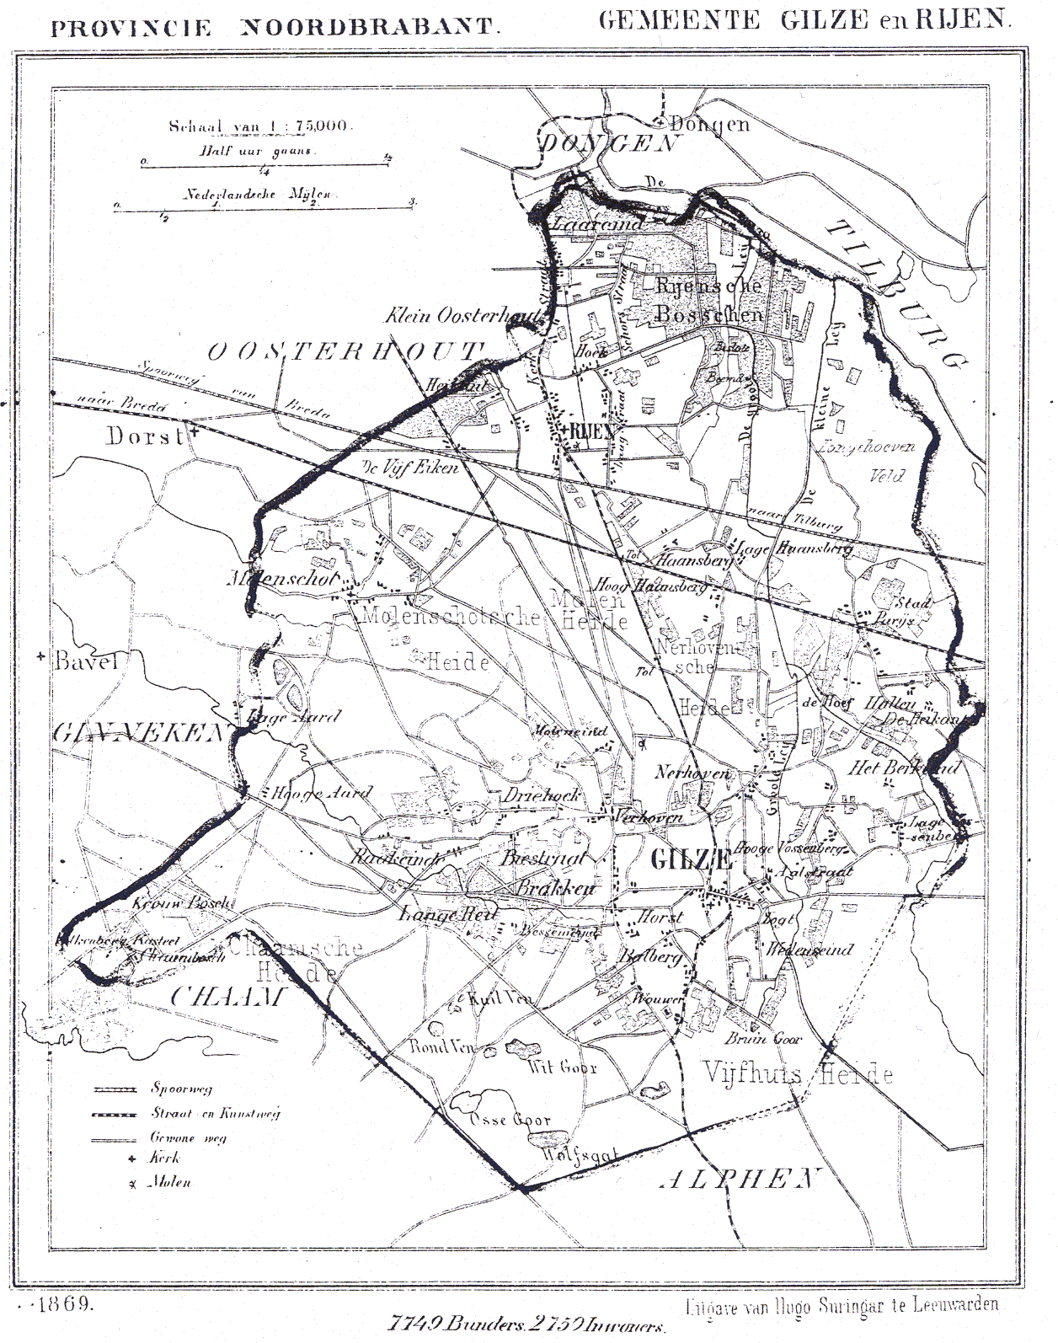
Map 1: Map of the community Gilze-Rijen in the province of Noord-Brabant, 1869.

While the machine readable data files of the family reconstitution have been preserved, it is no longer available with its original database software. We were nevertheless able to access the information in the original data files with help of the surviving codebook. In total the database consists of 9 tables (in the codebook referred to as records), covering information on the inhabitants of “Gilze en Rijen” from various sources. For our purpose, we shall mostly rely on record 2 in the database, which provides the composition of households on a yearly basis. In total, the record contains information on 26,922 cases for which 19,849 individuals are specifically registered to one of 1,962 households. However, as not for all of these observations the information we need is complete we will work on a selection of the data. We excluded 6 households with multiple heads of households that seemed implausible and another 232 households without a head of household. This reduces the sample to 25,747 individuals in 1,724 households. Another 238 households (550 cases) without information on years of entry or exit in the household we omit, leaving 1,486 households and 18,926 cases. Finally, to chart where one household starts and a new household begins, we define the start of a household as the first year in which a head of household or the wife of the head of household appears. Similarly, we define the end of a household as the last year where either the head of household or a wife is mentioned. To make sure we compare households at similar stages in their household life course, we only select households that in the first year of observation have at most one child. The selection based on beginning and end of the household and the number of children in the first observation year of the household reduces sample size further to 1,034 households. There is quite some variation in the length of observation of the households in our selected sample (and the database as a whole). At the extremes, 94 households (9%) are observed for just 1 year, while 1 household (.1%) is observed for 59 years. On average, households are observed for 19 years, with a median of 14 years. In total, we observed the households for 20,113 years. Table 1 provides an overview of other summary statistics used in the analysis below.
To answer the research questions we apply both descriptive and explanatory methods. Using state-sequence analysis we are able to determine what are common sequences in hiring servants and lodgers, taking into account the various stages households go through. We will use four states: empty, for households with neither servants nor lodgers; servants for households with servants; lodgers for households with lodgers; and full, for households with both servants and lodgers. Next we apply multilevel growth curve models to explain changes in the number of servants in the household over time. Using growth curve models we can specifically assess differences in the uptake of servants at the start of the household, as well as changes over time in the number of servants. Finally, we can enter covariates in these models to evaluate the influence of household characteristics, such as the presence of grandparents in the household.

For our analysis we have chosen to split up the household in three stages: the first 15 years of a household are prone to be rather difficult, with young children yet incapable of contributing to the household chores and income. As soon as the youngest children have reached the age at which they can be put to work (12-15), e.g. as an apprentice or as a helping hand on the farm, and thus can contribute to the income, the household can move into a –relatively- easier period. We estimate this period could be up to another 15 years. When all children have moved out and are now working to support their own household, the end of life-period, here estimated at 10 years, starts, which can again be a difficult period for the remaining parents. In particular the first and the last periods are thus periods in which the parents could use some support, first to help taking care of their children and later on to be taken care of themselves. In our analysis we will analyse to what extent households with children and those without, in each of these three phases, drew in kin and non-kin to help out. In order to make the step from dealing with the household composition and the relative importance of external help (servants) in the household on the one hand and the presence of other possible help, from relatives, we have per period calculated the “dependency-ratio”, whereby the number of years within each period there are servants to be found is calculated (note: we do not take into account the number of servants at this phase). We thus assume that if external help is “bought in” this is out of need because other help is not available. Whether this is the case is tested by using the presence of parents (of the head of household or his wife) and the presence of other kin as the dependent variables.
On the basis of the earlier on made assumptions related to the nuclear hardship theses we expect that phase1- and phase3- households draw in servants whenever there is no other kin available to help out. We expect that phase2-households are lesser in need of servants overall (unless they have their parents to take care of????-> thus is grandparents are living in they might want to have extra help???) and that gradually there would be more room for lodgers in the household as space is freed up by children that move out.

4. Results
Our main interest in this article goes to establishing in what type of households servants ended up, not on the basis of a momentary snap-shot but taking into account the long-term development of the household itself, in order to understand the demand for servants. However, before we focus on differences in household levels, we first discuss descriptive results of changes in households overall. Figure 1 displays for 6 household characteristics changes over time in the mean of that characteristic (in blue) and in the overall distribution of that characteristic by means of box-and-whisker plots (in grey).
Panel (a) in Figure 1 displays the size of households in our sample for each year between 1724 and 1809. Apart from an increase in the first decade and a dip around the French Invasion in 1795, the average household is rather stable throughout the 18th century in Gilze and Rijen, with households consisting of on average 5 persons. The boxplots clearly show the variation in household size, which is relatively stable as well in the 18th century. About a quarter of the households have less than 3 persons, half of the households have between 3 and 7 persons, while a quarter of the households consist of more than 7 persons.
The increase in household size may be explained by the increase in the number of children per household, see in Figure 1, panel (b). Other than that an increase of on average 2 children per household, the average number of children per household remains stable throughout the 18th century. We do however see more fluctuation in the number of children per household when looking at the boxplots. For example, in the second half of the 18th century, 75 per cent of the households had at least one child. But it is clearly visible that in certain periods, around 1753, 1780 and 1794, the number of children was much smaller. We can also see that the variation in the number of children increases in certain periods, such as in the 1760s and the first decade of the 19th century.
Panel (c) in Figure 1 portrays the number of servants per household. While on average households had one servant, the boxplots shows that this average is not representative at all. A quarter of the households in Gilze and Rijen never had a servant in the 18th century, while for several decades even half of the households had no servants. On the other hand in the 1750s and the last two decades of the 18th century some of the households in Gilze and Rijen had between two and five servants at least. Panel (e) in Figure 1 shows that lodgers were really a borderline phenomenon. Only a very small number of households incorporated lodgers each year in the 18th century.
Panel (d) and (f) in Figure 1 on respectively the number of parents-living in with their children or the number of other extended relations in the household confirm the dominance of the nuclear household pattern in Gilze and Rijen. The missing whiskers on the boxplots in panel (d) and (e) indicate that at the very most a quarter of the households had either a parent or other relative living in.
In sum, Figure 1 shows a rather stable composition of households in Gilze and Rijen for most of the 18th century. However, this stable composition also indicates static inequalities between households, such as in the presence of children, extended relations and servants.

[FIGURE 1 about here]

The question then emerges whether there was there a link between the composition of the household and the presence of servants? Of course, every household is different in terms of timing of the important life-events, such as marriage and having children, in terms of the size of the household and the distribution of sexes within that household, in terms of the period when it was composed, developed and dissolved. To gain a better understanding of the sequences that exist in deploying servants and lodgers Figure 2 shows a state distribution plot for all sequences in our sample (of 1,034 households), for the first 40 years in the household. The x-axis displays time in years and on the y-axis we find the proportion of households in one of four states: empty, servant, lodger and full.

Let us now focus more on the position of servants and lodgers in the life cycle of a household. Figure 2 reveals a number of patterns in the deployment of servants and lodgers over the life course of the household. In the first years the proportion of households with servants increases. While a relatively small group that does more or less remain the same size throughout the whole cycle, it is clearly visible that also the proportion of households with lodgers increases somewhat over the course of the first few years. After 5 years both the proportion of households with servants and the proportion of households with lodgers decreases until the household exist about 25 years. Thereafter, the proportion of households with either servants or lodgers, or both, increases again. It is clear that in particular in the first years of a household the presence of servants was needed, and that also towards the end of the life-cycle of 40 years the presence of servants becomes more likely again. This is in line with the broad picture that we have sketched before but the question remains to what extent this is linked to the presence of other kin in the household, parents(-in-law) or other kin (nieces, nephews, uncles, aunts etc.). Considering that we do not have any data on the ages of the people moving in, we need to rely on more general assumptions, i.e. that parents who live with their children (at the age of approx. 50) in phase 1 might still help the latter out in the beginning but that at some point they will become dependent on their own children.

[FIGURE 2 about here]

The analysis whereby we look at the various stages of the household is done on a subsample of 142 households which existed for at least 40 years, this to assure that we capture in particular those households for which we can analyse the three phases.
Table 2 provides the regression results of a generalized linear mixed model in which we regress the number of servants ('knechten', 'meiden', 'dienst-werkboden') on varous household characteristics. The table harnasses three models corresponding to the three time periods we distinguish. Since the dependent variable is a count variable we fit our models according to a poisson distribution. To control for overdispersion we ran the models in Table 2 with a random component on the observational level to control for yearly deviations from the poisson distribution. The variation of this random component is rather low (<0.000) and anova tests show that models controlling for overdispersion do not outperform models neglecting overdispersion. We therefore provide the models in Table 2 without the extra random component. All models are controlled for four variables: a linear and quadratic effect of time, the amount of tax paid in 1762 and the number of staff (personnel) that are not registered as 'meid', 'knecht' or 'dienst-/werkbode', but fullfill a more specific role, such as herder or gardner.
The first model in Table 2 shows that on average the number of servants in households increases and that those who paid more tax have more servants. It also shows that couples with no or just 1 child have less servants than those with 2 or 3 children (the reference category). To be more precise the incident rate of parents with no children or 1 child is only .82 (exp^{-0.204}) the incident rate of those with 2 or 3 children. We argued that having more children would lower the number of servants, since these children are able to help out in the household. Having more than 3 children indeed has a negative effect on the hiring of servants, but only in the 2nd and 3rd period, indicating that children indeed need to have reached a certain age, before they could replace labour of servants. This is clearly in support of our earlier formulated hypothesis.
Whether one is single or single parent as head of household does not seem to influence the number of servants in the household. The interaction of this effect with having at most 1 child indicates that less servants are needed than when having 2 or 3 children. The number of parents and parents-in-law does not seem to influence the intake of servants. The latter effect is not significant in the first period and although it is significant in the second, its effect is insubstantial. In the third period there are hardly any households with parents and we had to omit this variable from the model in order for the model to converge. We do see an effect of other family living in in the first period, indicating that it is especially in this period that living in kin are helping out. This form of help is not likely to be associated with just helping out with raising children, given the non-significant interaction effect of extended kin in the household with the number of children.
In the second period we see a clear distinction between the number of children in the household and the presence of servants. By now children have less need of care and some already are able to help out caring for younger siblings or performing work in the house or work on the land. This line of reasoning is supported by the positive effect of having no children or 1 child, as opposed to having 2 or 3 children, as well as by the negative effect of having more than three children (as opposed to having 2 or 3 children). These effects are quite substantial. The incident rate of having less than 2 children is 1.5 times the incident rate of having 2 to 3 children. Children also negatively influence the uptake of servants in the third period, but only when there are more than 3 children still living in the household.

The above analyses have made clear that having children in the household is clearly related to having servants, in particular in the first phase of the household. But how does this affect the rest of the life course of the household? Does having servant in the first phase of a household “predict” a pattern for the rest of the life of a household? In order to find this out we suggest another type of analysis which can help us to understand the types of households in the villages we deal with here. It can be assumed that not all the households show a similar pattern in taking in servants, because they vary in wealth, they vary in household composition and in, no doubt, many other factors. Those factors are however hard or impossible to check on the basis of our data. But we can analyse how the presence of servants –and lodgers- followed a similar pattern throughout the “life” of a household and to what extent these patterns were present in the society we study. We study the most common sequences in taking up servants and lodgers by clustering of households based on their commonalities in the uptake of servants and lodgers. (For this analysis we –again- use the large sample as the length of the households would not necessarily influence whether they belong to one type or another).

[FIGURE 3 about here]

Figure 3 displays four clusters of households, with clearly distinct patterns in taking up servants and lodgers (including all 1.034 households of the sample). Slightly less than half of the households in the sample could be “fitted” in the first cluster, about 30% of the households was of the Cluster2-type. Cluster 3 and 4 were each present in the sample for approx. 10%. In Cluster 1 only a small proportion of households invested in servants at the very start of the household, but then the proportion of households with a servant increases rapidly in the first ten years of the household, after which it stagnates for a while. After a period of approx. 20 years, a substantial number of the households has both a servant and a lodger in the house and in the very last phase of the household’s life cycle this has become the standard combination.
Clusters 2 and 3 are similar to each other in the sense that they show little variation in the proportion of households with a servant over time. However, the existing variation shows increases in the proportion of servants at the beginning and end of the household life course, in line with the notion of nuclear hardship. Clusters 2 and 3 are fundamentally different in the overall levels of servants that appear in households in these respective clusters. In Cluster 2 the proportion of households with a servant is around 20%, while in Cluster 3 this is around 80%. Considering that these latter households seem to hire servants throughout their lifetime, this might well represent the wealthier part of society to which servants are usually attributed. The opposite, as in cluster 2 could very well represent the 10% poor households we have already spotted elsewhere in the Netherlands (Bouman and De Moor, 2012) as being involved in hiring servants but to a more limited extent.
Finally, Cluster 4 also shows an increase in the number of servants in the beginning and end period of the household’s life course. However, what is truly characteristic about Cluster 4, is the big difference between the beginning and end of the household. In the beginning nearly 80% of all households have at least one servant, but after two decades this has decreased to about 20%. This cluster is to some extent similar to cluster 1 but in terms of the end of life-phase rather different.

In sum, in three of the four clusters the timing of the uptake and release of servants is in line with arguments on the timing of spells of nuclear hardship. In particular cluster 1, which is also the most dominant in the whole sample, demonstrates features of what could be expected on the basis of the described forms of hardship: a substantial number of households had servants in the earlier years of the household. Cluster 1 does however not show a decline in the intake of servants during the “easier” years, in the middle of the life-cycle. What we do find, however, is that servants are now frequently complemented with lodgers, possibly to compensate for the presence of a servant and to allow for some extra income at a moment when the oldest children –around the age of 20-22- start moving out of the household. What is striking and in line with the earlier proposed hypothesis of the commercial household is that many households combined of servants and lodgers at the same time within the household, instead of in sequence.

5. Conclusion and discussion
In this article we have tried to shed light on the timing of hiring servants and have especially tried to answer the question of whether the uptake of servants was related to spells of nuclear hardship.
The descriptive results have shown that there indeed are patterns in the uptake of servants and these patterns can, to a large extent, be linked to spells that are associated with nuclear hardship: the beginning and end of the household life course. However, it also showed that the differences between households in taking up servants were much larger than differences related to spells of nuclear hardship. This finding was corroborated in the explanatory results, where there appeared to be much variation between households in the uptake of servants. Clearly, the demand for external labour is linked to the possibility of children helping out in the household. The very few households with parents(-in-law) living in, demonstrates that the parents were not a party to count on when needed and that indeed they might have had to rely on servants themselves.
While we set out to study differences in the uptake of both servants and lodgers, we found relatively few lodgers and these lodgers seemed furthermore to be residing in one particular type of household. Lodgers were mainly taken up in the later stages of the household life course, often in combination with a servant.

6. References
Berkner, Lutz K. “The Stem Family and the Developmental Cycle of the Peasant Household: An Eighteenth-century Austrian Example.” The American Historical Review 77, no. 2 (1972): 398–418.
Bryson, B. "At Home: A Short History of Private Life". (2010). New York: Anchor Books.
Blaikie, Andrew. “Nuclear Hardship or Variant Dependency? Households and the Scottish Poor Law.” Continuity and Change 17, no. 02 (2002): 253–280. doi:10.1017/S0268416002004204.
Bouman, Annemarie, Jaco Zuijderduijn, and Tine De Moor. From Hardship to Benefit: A Critical Review of the Nuclear Hardship Theory in Relation to the Emergence of the European Marriage Pattern. Utrecht University, Centre for Global Economic History, 2012. http://www.collective-action.info/sites/default/files/webmaster/_PUB_HardshipBenefit_WP.pdf.
Harris, Richard. “The End Justified the Means: Boarding and Rooming in a City of Homes, 1890-1951.” Journal of Social History 26, no. 2 (December 1, 1992): 331–358. doi:10.2307/3788424.
McGill, Robert, John W. Tukey and Wayne A. Larsen. "Variations of Box Plots", The American Statistician 32, no. 1 (1978): 12-16.
Laslett, Peter. “Family, Kinship and Collectivity as Systems of Support in Pre-industrial Europe: a Consideration of the ‘nuclear-hardship’ Hypothesis.” Continuity and Change 3, no. Special Issue 02 (1988): 153–175. doi:10.1017/S026841600000093X.
Klep 1973, AAG bijdragen
Kok, Jan and Kees Mandemakers. “Nuclear Hardship in the Nuclear Heartland? Families and Welfare in the Netherlands, 1850-1940.” Accessed June 7, 2013. http://soc.kuleuven.be/ceso/historischedemografie/resources/pdf/WOG%20working%20paper16.pdf.
Ruggles, Steve. "The future of Historical Family Demography", Annual Review of Sociology 38, (2012): 423-441.
Smith, James E. “Widowhood and Ageing in Traditional English Society.” Ageing and Society 4, no. 4 (1984): 429–449.
Verreyt, Ch.C.V. 1914. “Brand te Gilze in 1762.” Taxandria 21: 63-65.

Tables

Table 1. Summary statistics

HSHDi mb1 mb2 mb3 mb4
Min. : 2 Min. :0.00 Min. :0.00 Min. :0.00 Min. :0.00
1st Qu.: 398 1st Qu.:0.00 1st Qu.:0.00 1st Qu.:0.00 1st Qu.:0.00
Median : 813 Median :0.00 Median :0.00 Median :0.00 Median :0.00
Mean : 858 Mean :0.19 Mean :0.43 Mean :0.21 Mean :0.16
3rd Qu.:1326 3rd Qu.:0.00 3rd Qu.:1.00 3rd Qu.:0.00 3rd Qu.:0.00
Max. :3683 Max. :1.00 Max. :1.00 Max. :1.00 Max. :1.00

Year hhsize nrserv nrlodg nrchild
Min. :1724 Min. : 1.0 Min. : 0.0 Min. :0.0 Min. :0
1st Qu.:1753 1st Qu.: 3.0 1st Qu.: 0.0 1st Qu.:0.0 1st Qu.:0
Median :1772 Median : 5.0 Median : 0.0 Median :0.0 Median :2
Mean :1771 Mean : 5.1 Mean : 0.9 Mean :0.1 Mean :2
3rd Qu.:1791 3rd Qu.: 7.0 3rd Qu.: 1.0 3rd Qu.:0.0 3rd Qu.:3
Max. :1809 Max. :19.0 Max. :13.0 Max. :4.0 Max. :9

nrextended nrparents nrgrandrel nrgrandpar nrextother
Min. : 0.0 Min. :0.00 Min. :0.0 Min. :0 Min. : 0.0
1st Qu.: 0.0 1st Qu.:1.00 1st Qu.:0.0 1st Qu.:0 1st Qu.: 0.0
Median : 0.0 Median :2.00 Median :0.0 Median :0 Median : 0.0
Mean : 0.3 Mean :1.74 Mean :0.1 Mean :0 Mean : 0.3
3rd Qu.: 0.0 3rd Qu.:2.00 3rd Qu.:0.0 3rd Qu.:0 3rd Qu.: 0.0
Max. :10.0 Max. :3.00 Max. :9.0 Max. :1 Max. :10.0

alt.start alt.stop hhyears extended three.gen
Min. :1724 Min. :1725 Min. : 0 Mode :logical Min. :0.00
1st Qu.:1735 1st Qu.:1774 1st Qu.: 5 FALSE:16064 1st Qu.:0.00
Median :1752 Median :1789 Median :13 TRUE :4049 Median :0.00
Mean :1755 Mean :1787 Mean :16 NA's :0 Mean :0.03
3rd Qu.:1774 3rd Qu.:1808 3rd Qu.:24 3rd Qu.:0.00
Max. :1808 Max. :1809 Max. :59 Max. :1.00

state nrc.start one.parent state.fact
Length:20113 Min. :0.00 Min. :0.00 empty :11227
Class :character 1st Qu.:0.00 1st Qu.:0.00 full : 700
Mode :character Median :0.00 Median :0.00 lodgers : 669
Mean :0.28 Mean :0.26 servants: 7517
3rd Qu.:1.00 3rd Qu.:1.00
Max. :1.00 Max. :1.00

Table 2. Generalized Linear Mixed Model of number of servants on explanatory variables.
Fixed effects: | 0-14 years |  |  | 15-29 |  |  | 30-39
 | Estimate | Std. Error | Sig. | Estimate | Std. Error | Sig. | Estimate | Std. Error | Sig.
(Intercept) | -2.268 | 0.258 | *** | -3.343 | 0.326 | *** | -2.845 | 0.290 | ***
Year | 0.057 | 0.022 | ** | -0.052 | 0.021 | * | 0.036 | 0.034
Year² | -0.005 | 0.001 | *** | 0.002 | 0.001 |  | -0.002 | 0.004
Tax 1762 | 0.679 | 0.086 | *** | 0.829 | 0.107 | *** | 0.692 | 0.093 | ***
Single parent hh | 0.380 | 0.233 |  | 0.206 | 0.153 |  | 0.115 | 0.144
<2 children | -0.204 | 0.087 | * | 0.410 | 0.171 | * | 0.152 | 0.165
>3 children | -0.050 | 0.070 |  | -0.376 | 0.133 | ** | -0.274 | 0.134 | *
Personnel | -0.012 | 0.052 |  | -0.177 | 0.077 | * | 0.477 | 0.059 | ***
Other Extended family | -0.233 | 0.064 | *** | -0.129 | 0.080 |  | 0.010 | 0.092
Number of parents | 0.126 | 0.129 |  | 1.002 | 0.475 | *
Single par *<2 child’n | -0.723 | 0.279 | ** | -0.305 | 0.281 |  | -0.174 | 0.192
Single par *>3 child’n | -0.363 | 0.319 |  | 0.122 | 0.211 |  | 0.164 | 0.186
# parents * <2 child’n | -0.285 | 0.161 | . | -0.521 | 0.618
# parents * >3 child’n | 0.237 | 0.189 |  | -0.640 | 0.558
Other ext. fam * <2 child’n | 0.082 | 0.094 |  | -0.098 | 0.143 |  | -0.207 | 0.174
Random effects:
HSHDi Intercept | 2.007 | 1.417 |  | 2.871 | 1.694 |  | 2.187 | 1.479
Loglikelihood | -2205.913 |  |  |  |  |  | -1390.233
AIC | 4443.826 |  |  |  |  |  | 2806.466
n | 2097 |  |  | 2116 |  |  | 1412
N | 142 |  |  | 142 |  |  | 142

Figures

Figure 1. Households characteristics over time (n= 20,113, N = 1034)

Figure 2. State distribution plot of four household states.
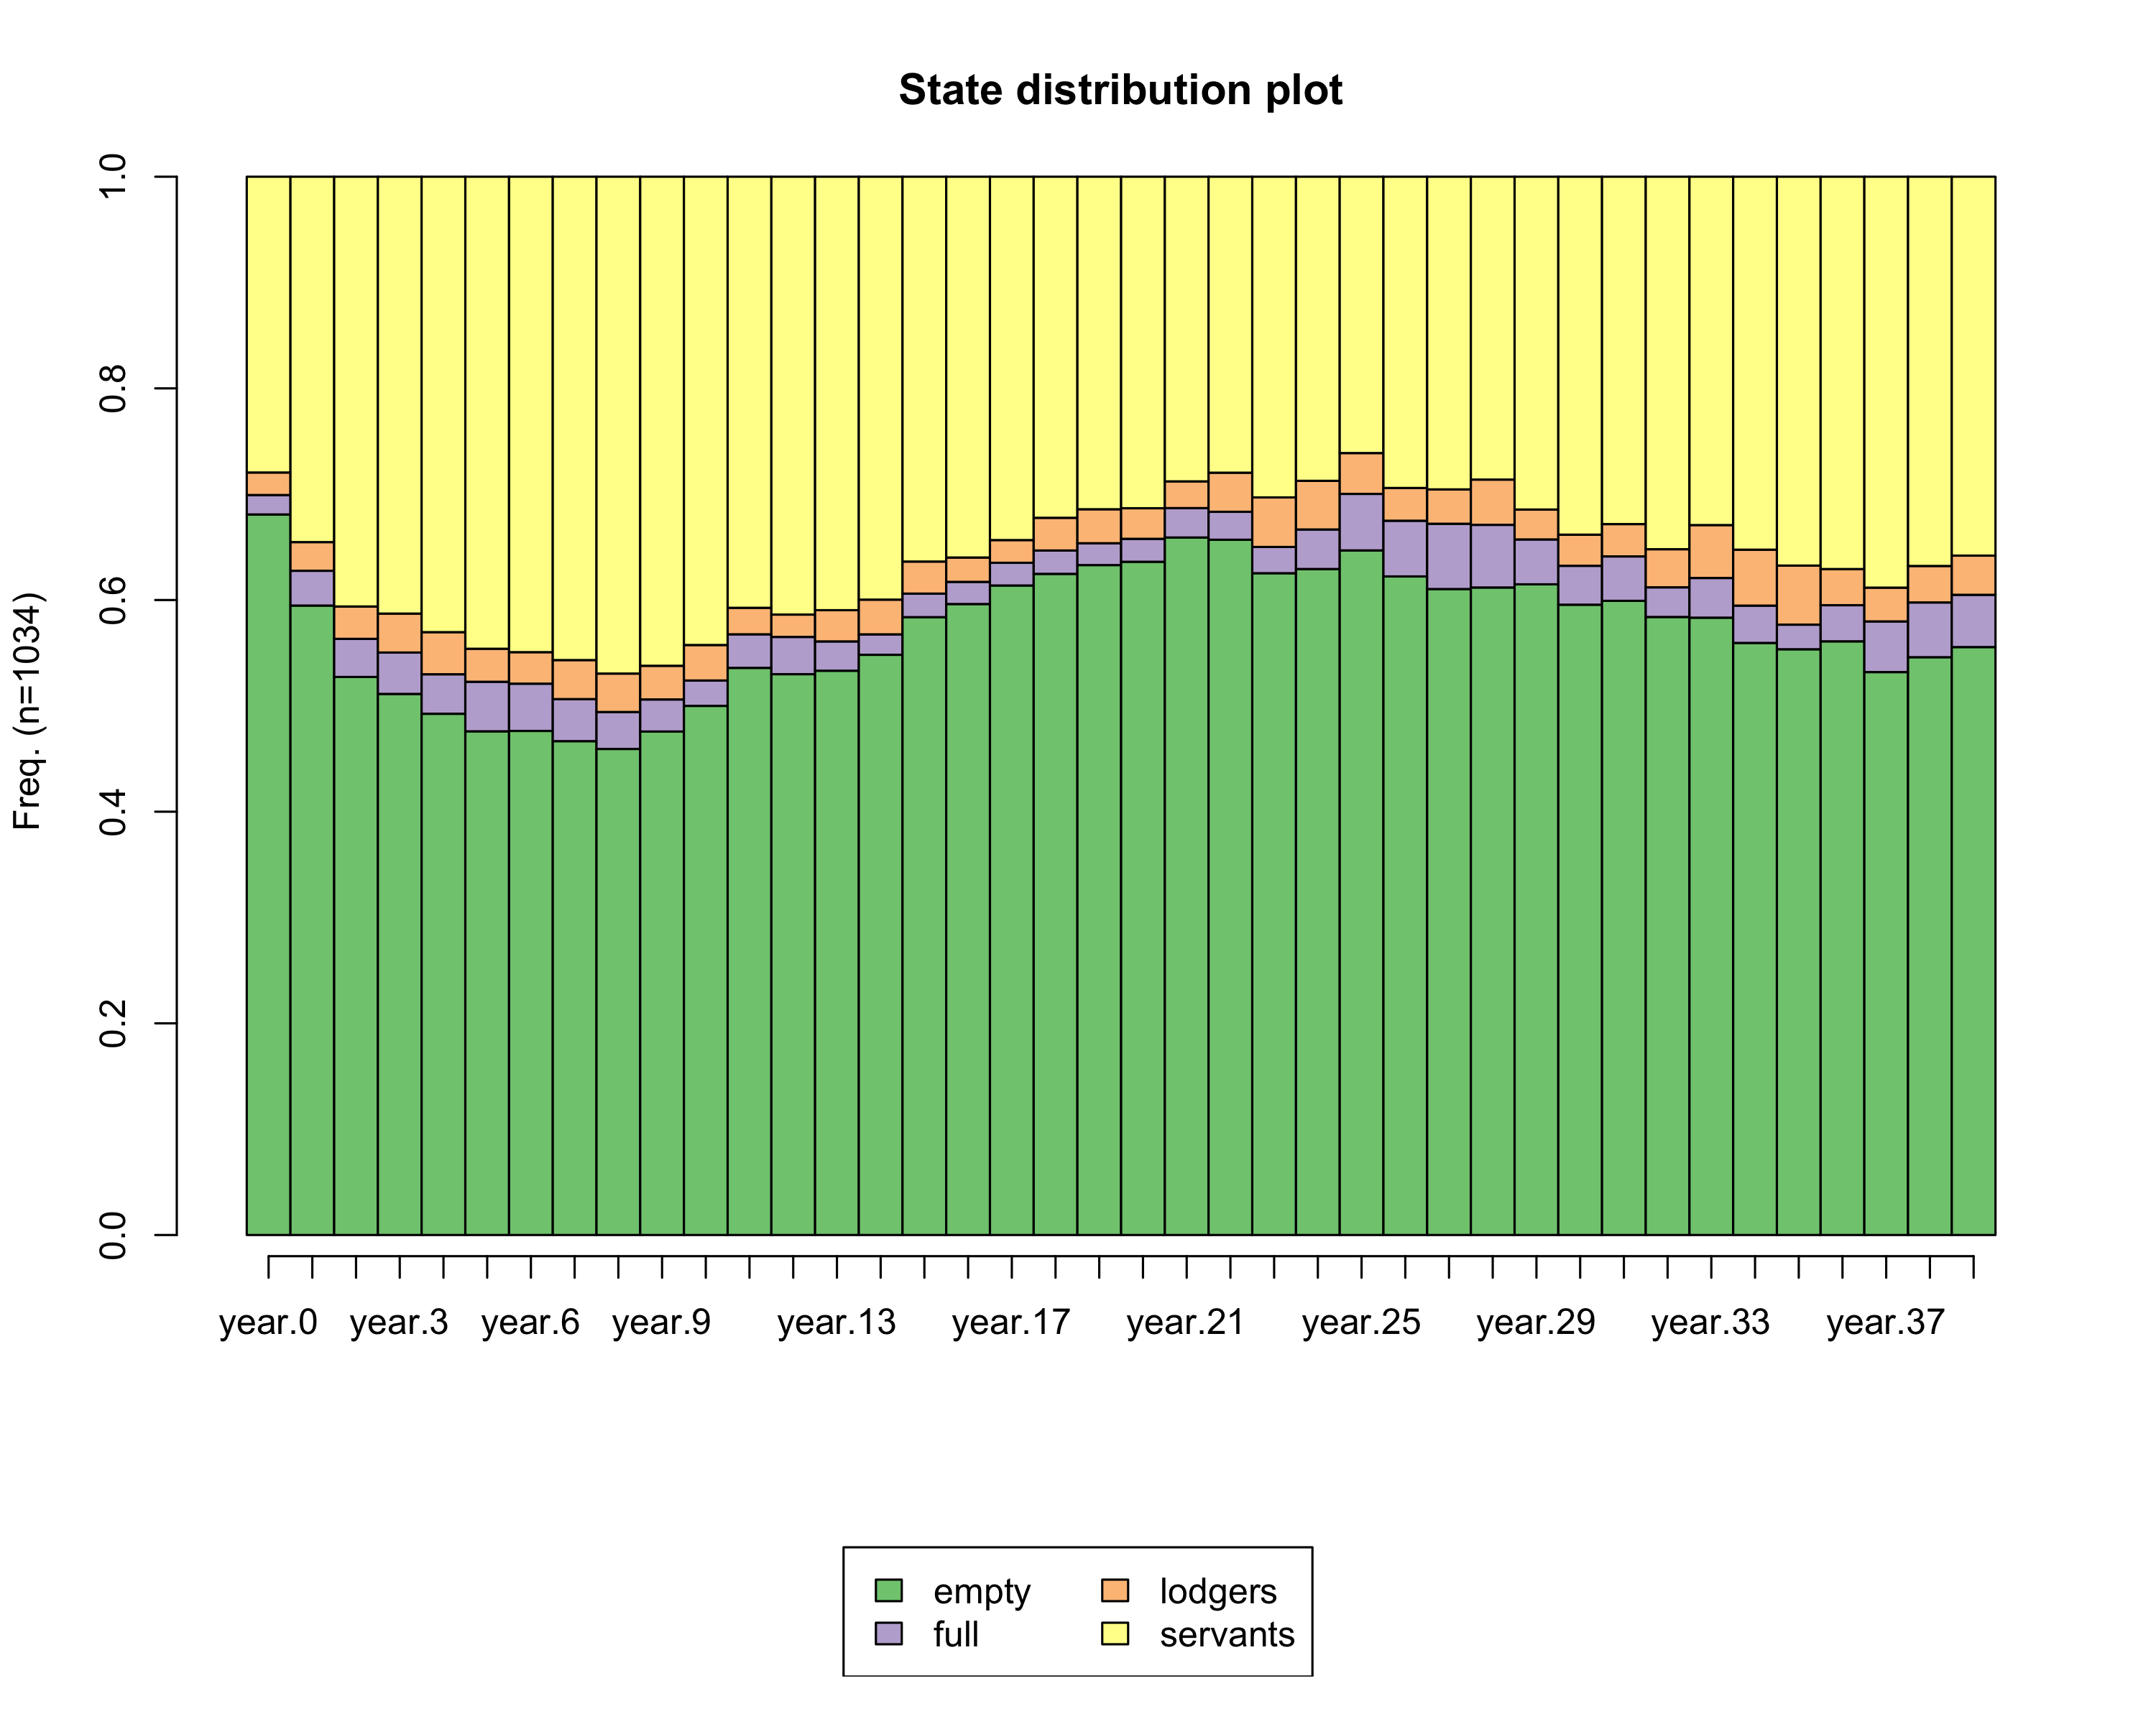

Figure 3. State distribution plot of four clusters.
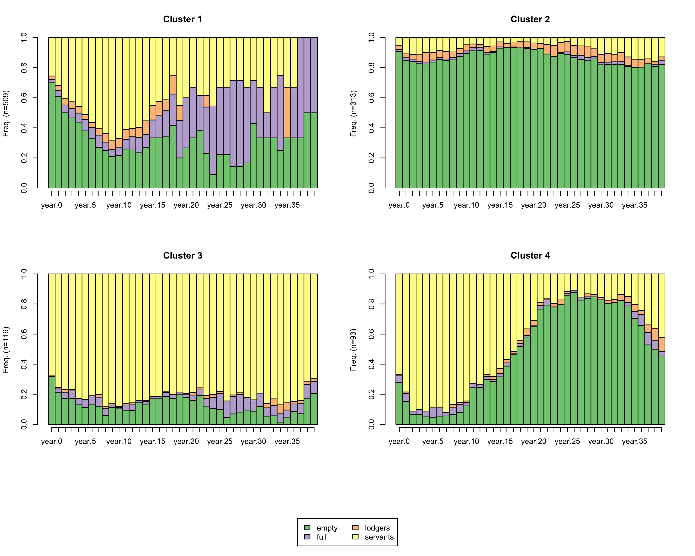

See e.g. the work by Laslett (1988) and many thereafter.
Cooper, Sheilagh McIsaac Cooper, in: “From family member to employee: aspects of continuity and discontinuity in English Domestic Service, 1600-2000”, p. 291 , in “Domestic Service and the Formation of European Identity: Understanding the ... edited by Antoinette Fauve.
The original data have been provided by Schellekens in a cases-as-rows format. The cases represent individuals. However, we are interested in phenomena on the household level. This means we needed to aggregate the data by household. A complication with aggregation of the household is that the data are given in a time-in-time-out format. That means the information that each row provides only applies to a specific time-period, the period that the person was observed in the household. Thus in order to aggregate the individual data to the household level, we need to make the time periods comparable. We do so by taking the smallest common time unit, which is year, and then aggregate data over year. For example, to calculate household size at each year, we would need to change the data format from this format: Household_ID Person_ID Year_in Year_out 1 1 1751 1753 1 2 1752 1753 2 1 1752 1753 2 2 1752 1753 2 3 1753 1753 into this format: Household_ID Person_ID Year.1751 Year.1752 Year.1753 1 1 1 1 1 1 2 NA* 1 1 2 1 NA 1 1 2 2 NA 1 1 2 3 NA NA 1 *NA means missing (not observed) Then we could sum the individuals values to for each household in each year in order to do the analyses for which the following format is required: Household_ID Year Household_size 1 1751 1 1 1752 2 1 1753 2 2 1752 2 2 1753 3
We are very grateful to Jona Schellekens who was willing to share his original dataset and provided us with good advice on multiple occasions.
Ruggles (2012, p. 434): “Time is curiously absent from much historical family demography. Most studies focus on specific communities at a particular moment or over a brief period. They sometimes study the effects of short-run economic, demographic, or political events on families but less often ex- amine secular trends. Among a dozen quantitative analyses of household structure published in the journal History of the Family during the past five years, only one-third looked at long-run change. [p434]
See for example the study by Paul Klep, A.A.G Bijdragen. Klep studied 5 sample years in between 1750 and 1849 but also recognizes the need for a study that deals with the evolution of the household.
See the 17th century reference made by Gregory King in Sheilagh McIsaac Cooper, in: “From family member to employee: aspects of continuity and discontinuity in English Domestic Service, 1600-2000”, p. 280, in “Domestic Service and the Formation of European Identity: Understanding the ... edited by Antoinette Fauve.
See again Cooper: “For most households having servants was not an indulgence or a social indicator but indicative of the labor necessary to maintain the house and family. A large servant staff for those not engaged in farming, inn-keeping or other labor-intensive business was a mark if social status or a symbol of what a later age would call conspicuous consumption.”, idem, p. 281.
See Berkner (1972) who reports that sometimes lodgers also worked for the head of household.
Harris (1992) p. 352 “Lodging served several purposes. For lodger and host it was not only a means of survival but also a method of saving capital, perhaps for a down payment. It made possible a higher level of home ownership and provided local housing markets with a degree of flexibility that they lack today.”
We would like to thank Jona Schellekens for generously sharing the database and providing feedback in recovering the information from the original database.
See W. Blankert, De huwelijksstruktuur in de Brabantse Kempen, in de periode 1830-1859, in Mederdelingen no. 4 van de afdeling historische geografie van het geografisch instituut van de rijksuniversiteit, Utrecht, 1967, p. 18.
Box- and whisker plots (boxplots hereafter) were designed to easily present information on the distribution of a variable (McGill, Tukey and Larsen, 1978). The upper and lower part of the box, referred to as ‘hinges’, indicate respectively the higher and lower quartiles, whereas the horizontal bar inside the box indicates the median. The whiskers start at the hinges and extend up to 1.5 times the interquartile range, the distance between the first and third quartile. Values beyond this ranges are considered to be outliers and graphically represented by a ‘+’.

